**Fanimation**

*User Guide*

|  |  |  |
| --- | --- | --- |
| **Supervisor** | Sir Salman | |
| **Batch** | 2206f | |
| **Group** | Fanimation | |
| **Serial**  **no.** | **Enrollment Number** | **Student**  **Name** |
| 1. | 1386763 | Ayesha |
| 2. | 1387493 | Ubaidullah |
| 3. | 1395115 | Ashwyn |
| 4. | 1395101 | Mark |

***User Guide***

**Fanimation:** This Website is basically based on fans. Through this website you can online order fan in different styles and designs that you like.

***Navigation Bar***

This is the Top of the page.

* User can know about the website by clicking on About Us button.
* Users can get touch to the admin by registering their self from this page.



***Home Page***

This page contains our latest unique fan designs.

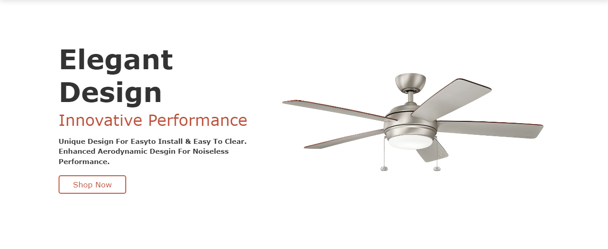

***Gallery***

This is the shop page.

* In this page user can order any fan that their need.
* In this page many categories of fans. such as (celling fan, fan accessories, pedestal fan, wall fan, exhaust fan and fan accessories.

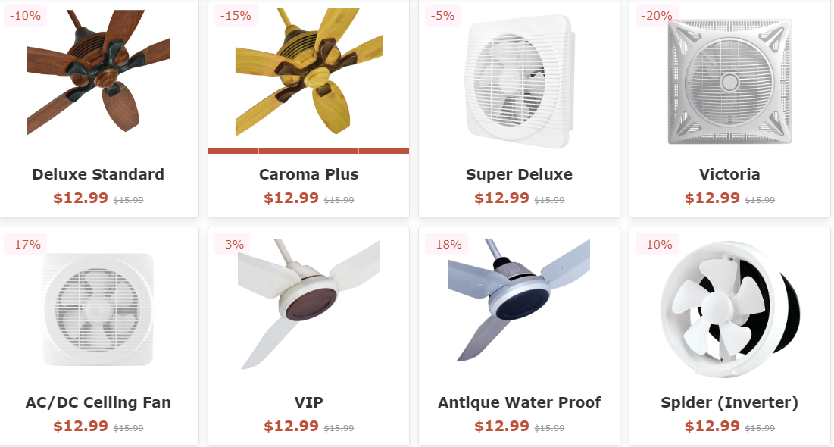

***Our Latest Product***

This page contains our latest product.

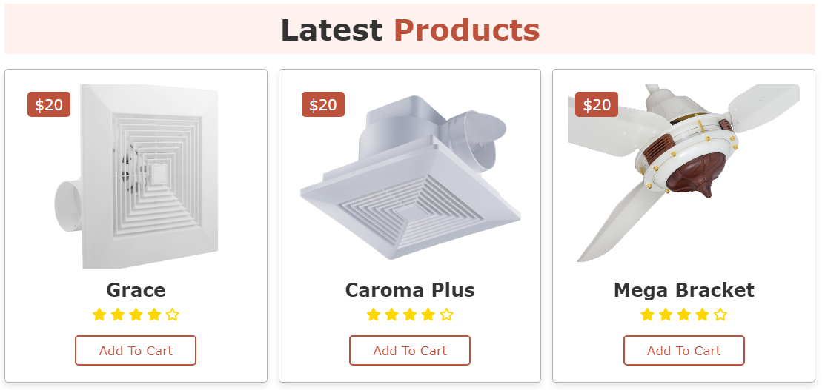

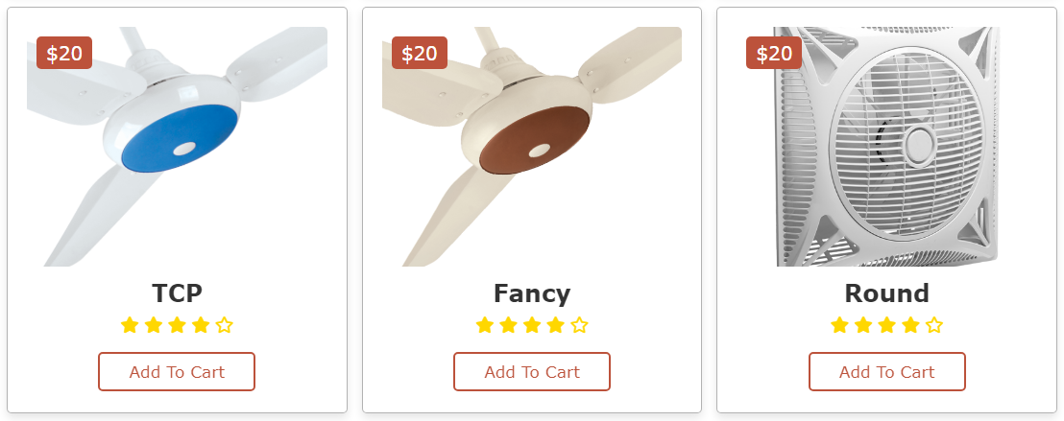

***About Us***

This is the About Us Page.

* This page has some Information about fanimation.



***Our Team***

This is our team Page.

This page has some Information about our team.

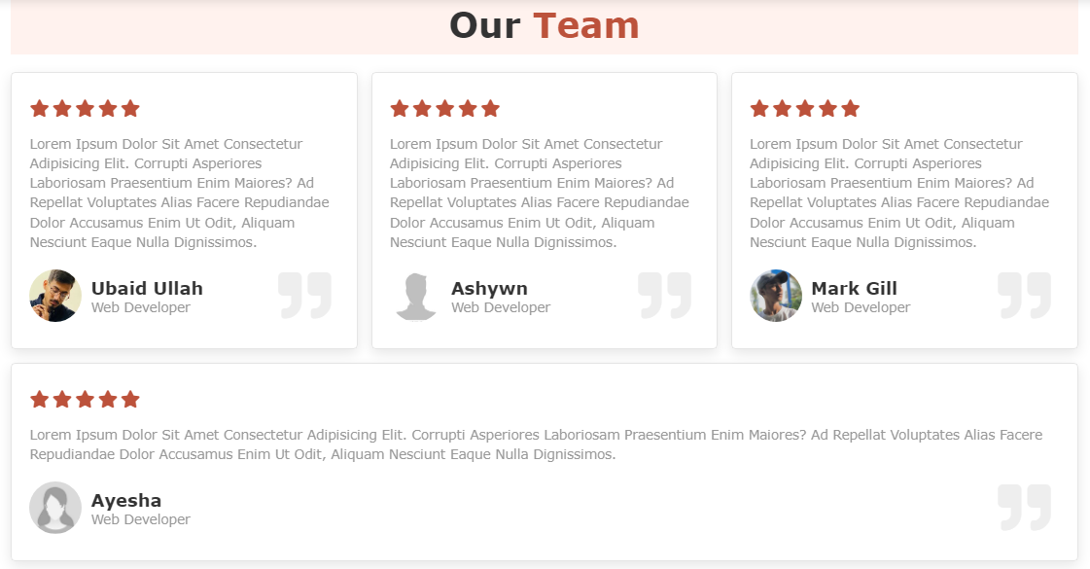

***Contact Us***

This is the Contact us Page.

* In this page users can get in touch with us.

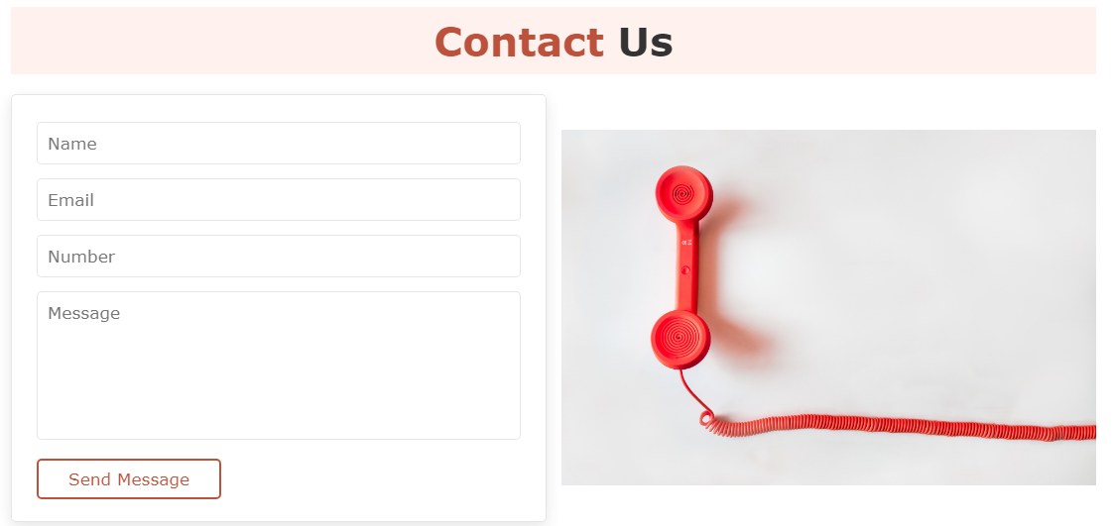

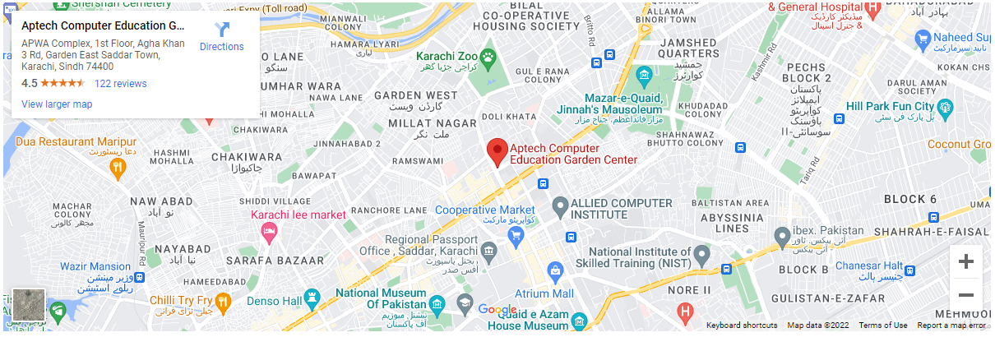

***Login/Register***

This is our login and registration page

* In this page first user can Register their-self, and then login.
* After Login user will be redirected to the Home Page and can see the more design of fanimation.

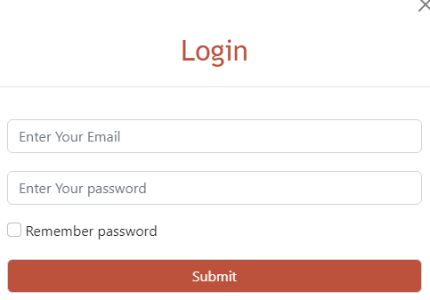

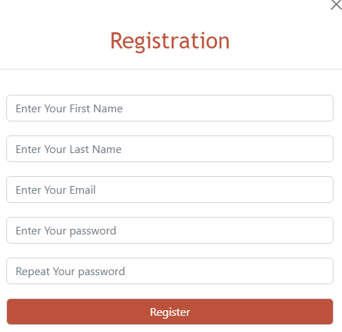

***Footer***

This is the Bottom of the page.

* It has some information of fanimation and our top categories of fans.
* Also mention in this page our email id, contact no, and Address.



***Thank You For Reading The Documentation****.*